
A GUIDE TO:

REGISTERING FOR JOEY CAMP 2024
Contents
I am a Joey Leader and need to register my Joeys: 2
How do I get some help? 5

I am a Joey Leader and need to register my Joeys:
Before commencing your registration, we recommend registering the entire joey unit so that you are aware of which of your unit members have registered as you will be able to access their registrations. If you find out that a joey will not be attending Joey Camp, you can cancel their application in your registration.
As the Joey Leader, you can register the Venturers online. The registration system will email each of the members that were registered, asking them to complete the consent forms and pay.
- Visit the ScoutEvent registration portal:
https://events.nsw.scouts.com.au/
- If you have used this portal before, please select Login and enter your credentials. If not, select Create user profile and set-up a new user account.
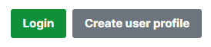
- Navigate to the event by clicking:
  - South Metropolitan Region
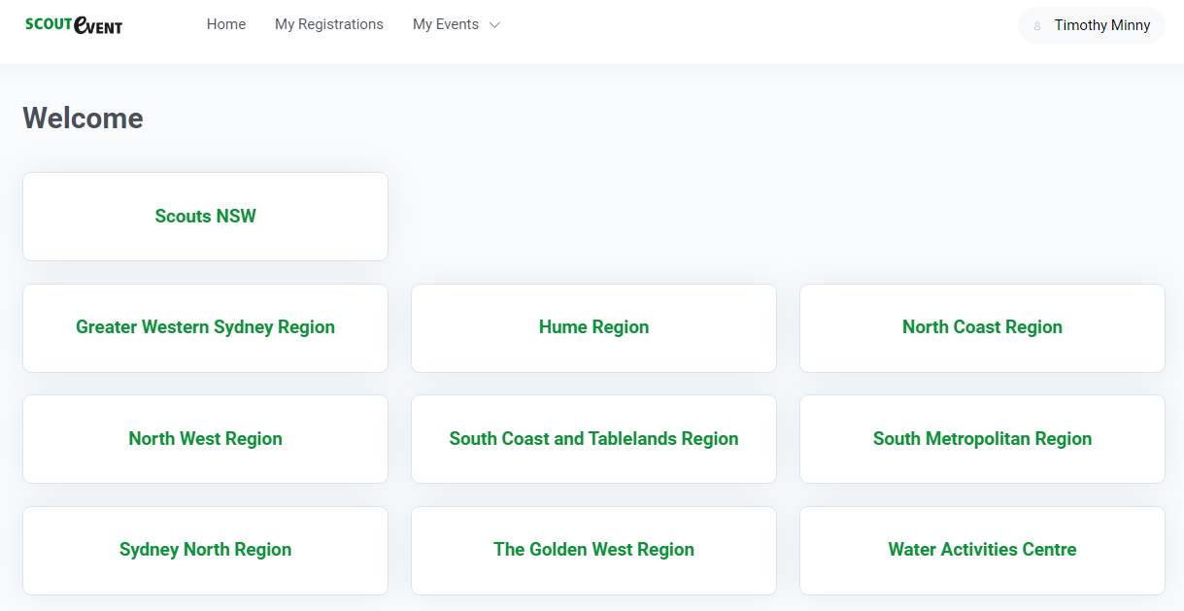
  - Scroll down to November 2024
  - Click on South Metropolitan Region – Joey Medieval Camp 2024
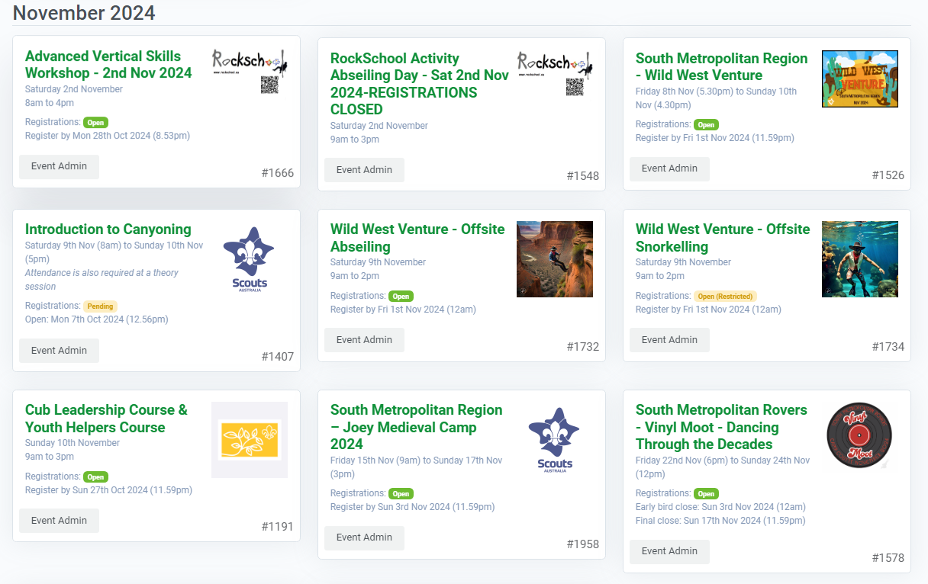
- Click Register Now from the Registrations portal
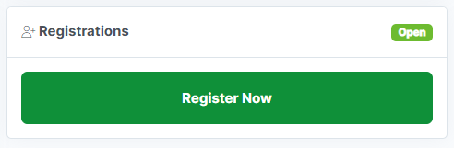
- Click + Add to begin adding yourself and members of your Group if you wish:
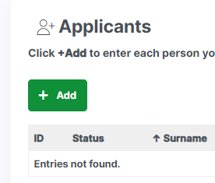
- For each member of your Group, including yourself complete the form. If you are adding another member to the Group, select Save & New. If you have entered the last member of your Unit, select Save & Return.
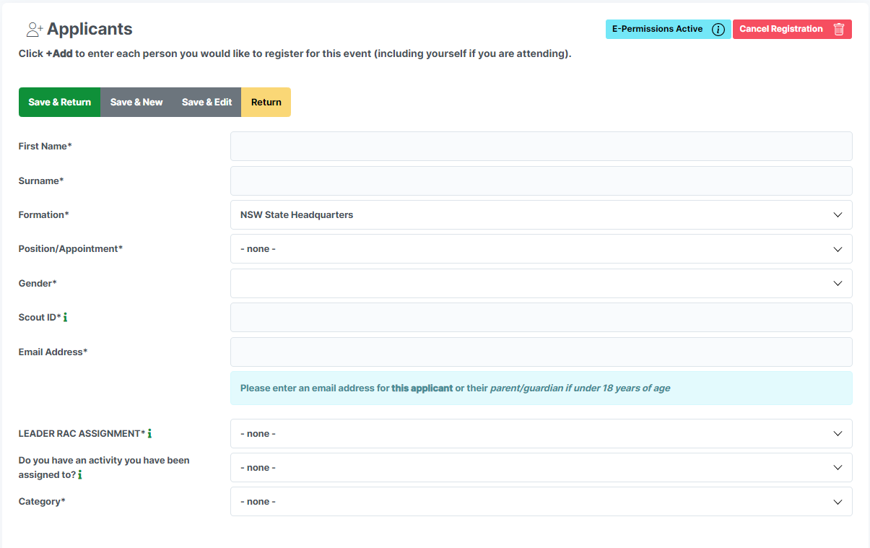
  - First Name
  - Surname
  - Formation – This is the Scout Group you belong to
  - Scout ID – This is the persons Scout Membership Number
  - Email Address – This should be the email address of each members parent or guardian. We send lots of emails here so please make sure it is correct.
  - Category – Select the appropriate category available at the time.
- After entering yourself or the members of your Patrol, click Save & Return to review your Group.
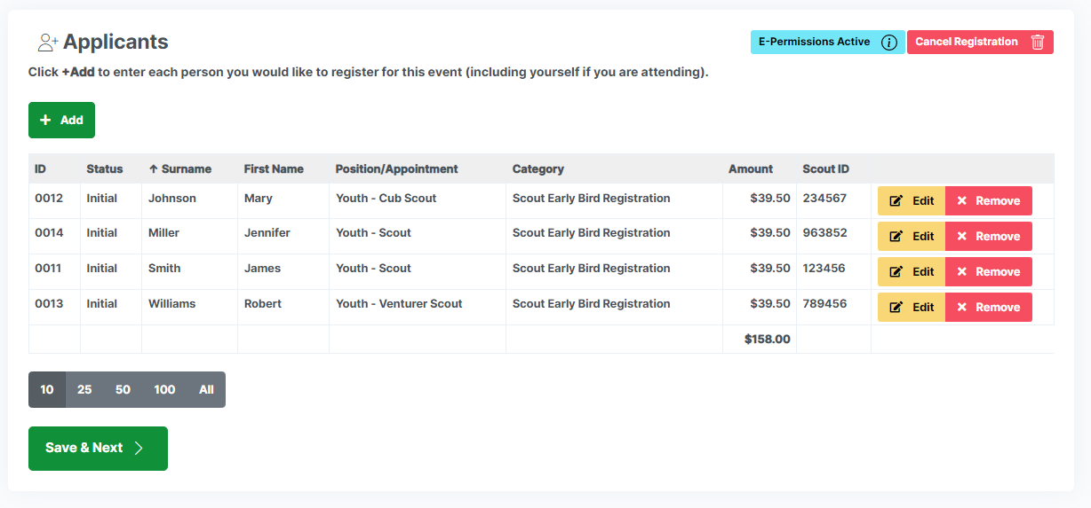
- If all details are correct, click on Save & Next. Otherwise you can continue to add members with the + Add option or edit / remove a specific member clicking the relevant option against their name.
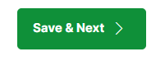

- If you have any comments, concerns, or things you want the Event organisers to know, please enter these now into the text boxes. Click Save & Next to continue
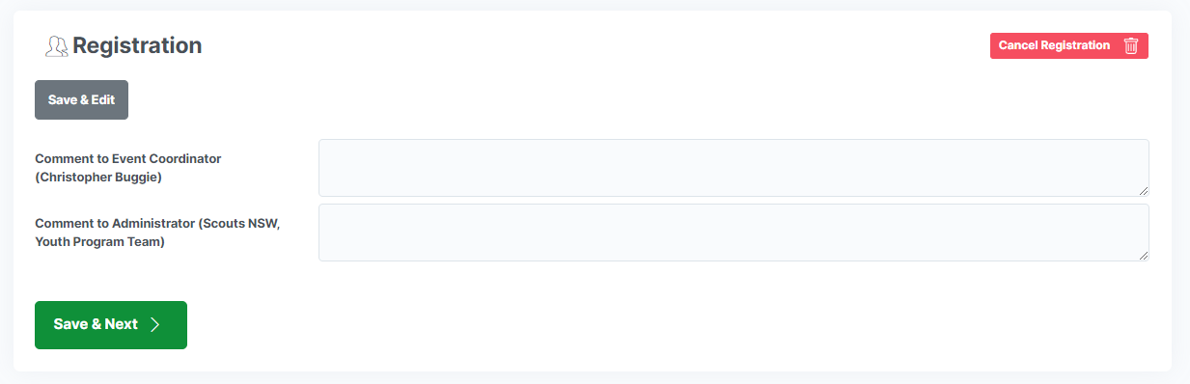
- Review your Group one last time. To ensure each member of your Patrol is asked to pay themselves, ensure you check the option Credit/Debit Card (via E-Permission Form). If you select just the option Credit/Debit Card you will be asked to pay for every member of your patrol.
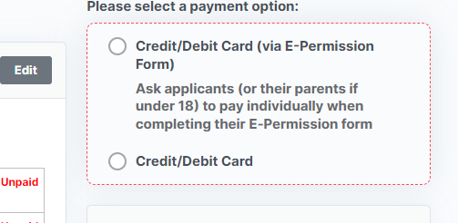
- Click the Submit Now button.
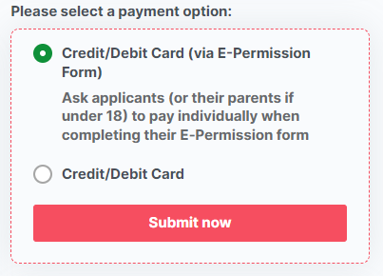

How do I get some help?

Having issues? Please, take a screen capture and email timothy.minny@nsw.scouts.com.au with a description of your issue and the screen capture. We will get back to you ASAP.

