14Scouts Australia - New South Wales
HUNTER & COASTAL REGION
45 Cowper Street WALLSEND 2287
P O Box 191 WALLSEND 2287

Phone: (02) 4950 0999
E-mail: hc.region@nsw.scouts.com.au
Office Hours: Monday to Friday 8.00 am to 4.00 pm


Dear Participant

CROSS COUNTRY SKIING at PERISHER # 2621

Friday (night) 10th to Sunday 12th July 2026

You have been accepted to participate in this event. The start is 9:00pm Friday night at the Jindabyne scout alpine centre.

LOCATION: Driving up the mountain each day to the Nordic Shelter opposite the Perisher Ski resort car park (other side of the road to Perisher’s Front Valley ski lifts).

START: 9:00pm Friday night for meet and greet, and go over equipment.

FINISH: planned to be around 1:00pm Sunday at Perisher Valley.

MAPS: Perisher Valley, 1:25,000 topographic. See attached Perisher topo and Trail Map

OBJECTIVE
The aim of the weekend is to learn how to get around on cross country skis, and experience camping in cold weather conditions. It is to introduce participants to cross country skis and the basic techniques for moving through flat and undulating landscape with snow cover. This weekend is to help gain experience and skills required to go back-country skiing and camping. There will be plenty of discussion and opportunity for questions, working in mainly large groups, but small groups at times, and hands-on skiing as much as possible.

TRAVEL
- This activity involves a lot of travel so please allow plenty of time to arrive on time Friday night. Allow at least 8 hours to drive from Newcastle to Jindabyne. If possible, try and have a relief driver - even one spare driver between two cars travelling together is safer.
- We have made a booking for Friday and Saturday nights at the scout Alpine Centre, The Barry Way, Jindabyne. Please let the course leader know if you are NOT staying on the Friday night, unfortunately the cost will still be the same.
- Travel down in groups and pick up your hire gear before you arrive at the activity.
- National Park Camping Fee to cover Kosciusko National Park are required for vehicles
- Please make sure your car has anti-freeze in the coolant (before leaving home) and if in a 2WD you are required to carry chains from Jindabyne into the national park.
- Need to consider how you will fit skis, boots, and poles in your vehicle from Cooma to Perisher and back (e.g. roof boot, roof rack, through the seats in the car).

COURSE
Saturday will be spent learning to ski on Cross Country / Back Country skis. For those of you have been downhill skiing before, learning to use Cross Country ski’s is a different skill set. Don’t worry if you feel like a beginner again, that is normal.
We will be camping down at Jindabyne at the scout Alpine Centre, 25 Barry Way, Jindabyne on Friday and Saturday night, then driving back up the mountain on Sunday.

Sunday is spent practicing your cross-country skiing skills. The activity will finish at the Nordic Shelter on Sunday afternoon. There is a rough timetable for the weekend, on the following pages.

COURSE LEADER – Tom Thorvaldson Please contact Tom on mobile 0402 822 093 or email on tom.thorvaldson@nsw.scouts.com.au if any additional information is required.

Please Note: Any Leaders applying for Skills days / weekend in Bushwalking this is NOT an accredited training course. If you wish to gain accreditation for Alpine or Bushwalking please refer to the RAT or State Training calendar for a BOS course near you. All accredited courses require eLearnlng prior to acceptance.

A few things for you to do:
Tick Off
1 | EQUIPMENT - you will need to bring your needs for the weekend including:  - A day backpack big enough to carry everything for a day in snow, including:  - Wet weather gear (jacket & pants)  - Insulation clothing layers, gloves, beanie, neck warmer  - Goggles, sunglasses, sunscreen, lip balm, sun hat  - Food (Sat lunch, Sun lunch, snacks, emergency rations) (occasionally there is a sausage sizzle on Sat lunch, money raised goes to the Nordic shelter)  - Water bottles  - First Aid kit.  - Mess kit and Cooking gear for Saturday night and Sunday breakfast – lunches won’t have time to be cooked.  - Food (Sat dinner, Sun breakfast)  - Trowel & toilet paper  - A good tent – or a share of one with your fellow venturers  - A sleeping mat to insulate you from the cold & potentially wet ground  - A below zero rated sleeping bag.  - Good hiking boots for around camp – preferably waterproof.  - Layers of clothing: DO NOT BRING COTTON OR DENIM CLOTHING  - Hat for during the day, beanie &/or balaclava for the night  - Thermals, shirt, jumper, jacket  - Zip off pants are good, or board shorts with thermals.  - Thermal pants are advisable for the campsite  - Dry socks and underwear for the 2nd day.  - National Park Camping Fee vehicles that cover Kosciusko National Park
2 | DRESS - suitable for cold conditions, and access to wet weather and insulating clothing (e.g. gloves, beanie etc.) and able to be identified as Scouts - scarf / group camp shirt / uniform etc.
3 | CAMP SITE – Scout Alpine Base, 25 The Barry Way Jindabyne
4 | HIKING EQUIPMENT – The purchase of a backpack, snow equipment and sleeping bag can be an expensive outlay. If you make the right choice these can last over 10 years and become a best purchase.
5 | Ski Hire - Skis, poles, & boots (OR Snow shoes & boots). Group booking will be organised from Rhythm in Cooma. Let them know you are from Hunter and Coastal Region Scouts. Please contact the COURSE LEADER Tom Thorvaldson and provide him with your height, weight, and shoe size to ensure Rhythm have an idea of skis, poles, and boots sizes.
6 | ANY CANCELLATIONS – if you are no longer able to attend this course please let the Region Office know on 4950-0999 before the activity commences or a refund will not be given. Please also let the Course Leader know.
COSTING – here’s the rough costings you should allow for:
$70 for skis, boots and poles – if we get a group booking it should be less than this.
$29 per car per day, roughly $10 per person per day. We will car pool up the mountain.
$30 Food on the way to the snow and back.
$50 Shared petrol costs (~$50 per head).
The course fee includes the camp site fee at Jindabyne for 2 nights.
$220 all up, plus there is often a BBQ lunch available for a small price at the Nordic Shelter however this should not be relied upon.

Other Information
Check out www.perisherxcountry.org for information on trails and safety.

Check out www.perisher.com.au/weather-cams/snow-conditions-reports/cross-country-report.html for information on the weather and the condition of the cross-country trails.

You will NOT need to carry your full weekend gear on the snow but will need to take clothing and equipment for a day trip and emergency. You will still need appropriate gear for camping in the snow (as it can snow at the camping ground) and alpine conditions. It is recommended that you use the equipment you intent to use for backcountry camping in the snow to test everything out.

You will be expected to take all food and cooking gear for your own needs, you will also need a good tent, sleeping mat, sleeping bag, warm clothes, waterproof jacket, good boots (if using snow shoes), map and compass (check the gear list from the Alpine Preparation Course – ask for a copy if you can’t locate a copy).

Uniform is not required, but all participants should be identifiable as Scouts for the travel and the weekend – group scarf or group camp shirt are OK.

A group booking for skis boot and pole will be organised. Details will be sent to the leaders attending the activity (further information in attached).

Transport is being organised by each group, talk to your Venturer Leader about what arrangements are being made for your group. Some car-pooling may be available.

Maps for the trip include Perisher Valley, 1:25,000 topographic (available with the instructor). See attached Perisher Topographic and Trail Map (bring this one with you in a suitable plastic sleeve or glad bag) and a compass.

The Regional Activity Team (RAT’s) look forward to having you on the activity and trust you find it both an enjoyable day and very useful as previous participants have found.

Yours in Scouting

Greg Denning
Regional Commissioner Activities
Per:

GEAR LIST

- Skis, poles, boots OR Snow shoes & boots. Remember to try on more than one set of boots before making a decision. Group booking will be organised from Rhythm in Cooma.

- Camping items: tent, mattress, sleeping bag, pillow.

- Cooking items: (Saturday dinner, Sunday breakfast): pots, pans, food – a BBQ and ovens/cook tops are available in the camp kitchen. CAMP CHAIRS NOT Required.

- Around camp: warm clothes, layers, water resistant boots (or other dry & warm shoes), towel, toiletries.

- On the snow:
  - Compulsory safety items: First aid kit, Map, Compass, waterproof jacket and pants, beanie or balaclava, sun glasses or ski googles (or both), gloves
  - Layers of clothing: Depending on conditions you could be:
    - Skiing in board shorts and t-shirts and sweating.
    - Wearing everything you own and still be cold.
  - Back pack to carry gear for the day, some food (snacks + lunch), and some water.

- If you have any questions about what to bring talk to your Venturer Leader or the Activity Leader.

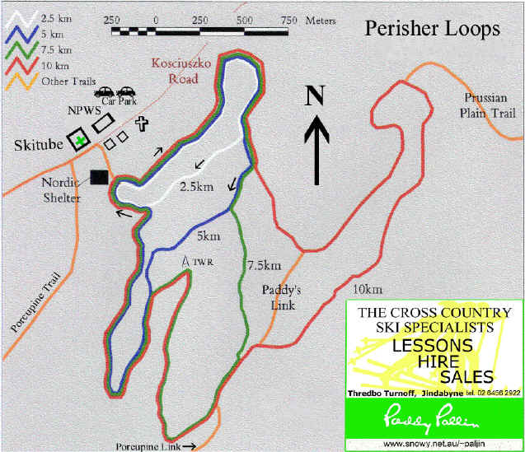
MEETING POINTS & TIMES

FRIDAY

- 9:00 pm – Jindabyne scout alpine centre, The Barry Way, Jindabyne. Don’t worry if you are late, this is more an informal go over equipment session.

SATURDAY
- 7:00am leave Jindabyne! We must be on the road by 7am, or the traffic gets terrible.

- Saturday Morning, 1st session – Drive to Perisher X-country ski area, Work on your cross-country skiing skills. Each group will have a mix of skiing ability, those Venturers who have been before and can ski well (often better than the leaders), will be able to instruct those first timers.

- 12:30 am – NORDIC SHELTER – lunch and reorganise groups (based on skills).

- 2nd session - In the afternoon proceed to work on the groomed Perisher Loop trails – starting with the 2.5km – then add parts to that as the group progresses

- 3 pm – NORDIC SHELTER – regroup at the hut before leaving - proceed back to campsite

SUNDAY

- 7:00 am – DEPART camp site – return to NORDIC SHELTER

- 9 am – NORDIC SHELTER – reorganise groups if required before heading out.

- 3rd session - head up toward the top area of the groomed trails, via the trees and trails. Generally, stay within the plateau area around Prussian Flat area. Do not drop off the hill side beyond the flat to the south

- 12:30 am – NORDIC SHELTER – lunch and reorganise groups.

- 1 pm – NORDIC SHELTER – regroup at the hut before finishing the course and depart for home

- On way home you will need to return gear to Cooma

PERISHER VALLEY – CROSS COUNTRY AREA

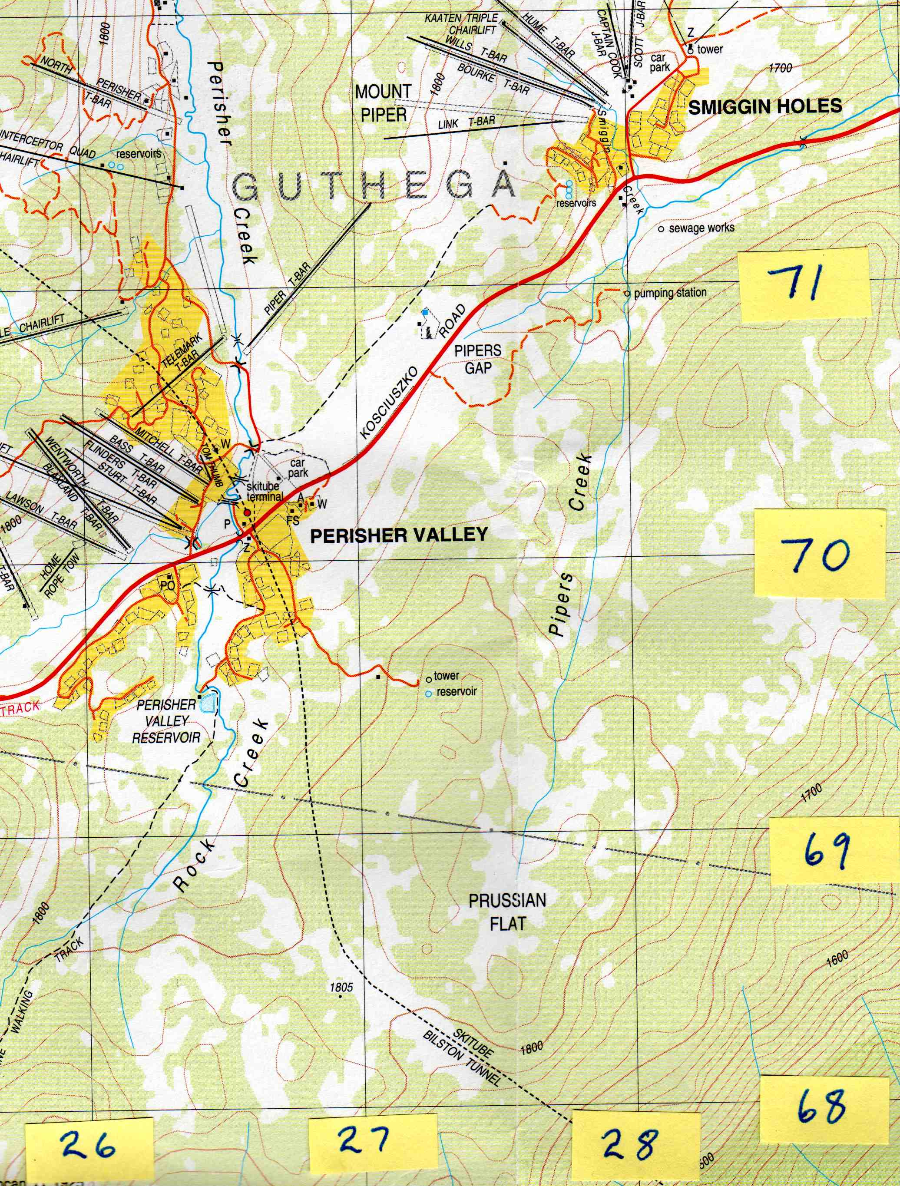

Contour interval is 20 m Magnetic variation = 13 degrees east
Enlarged extract from PERISHER VALLEY 1 in 25,000 topo – new series = MGA grid

Nordic Shelter grid reference 267 701 (Easting 267 Northing 701)

