2026 Towarri National Park Hike
19 Sept – 20 September 2026

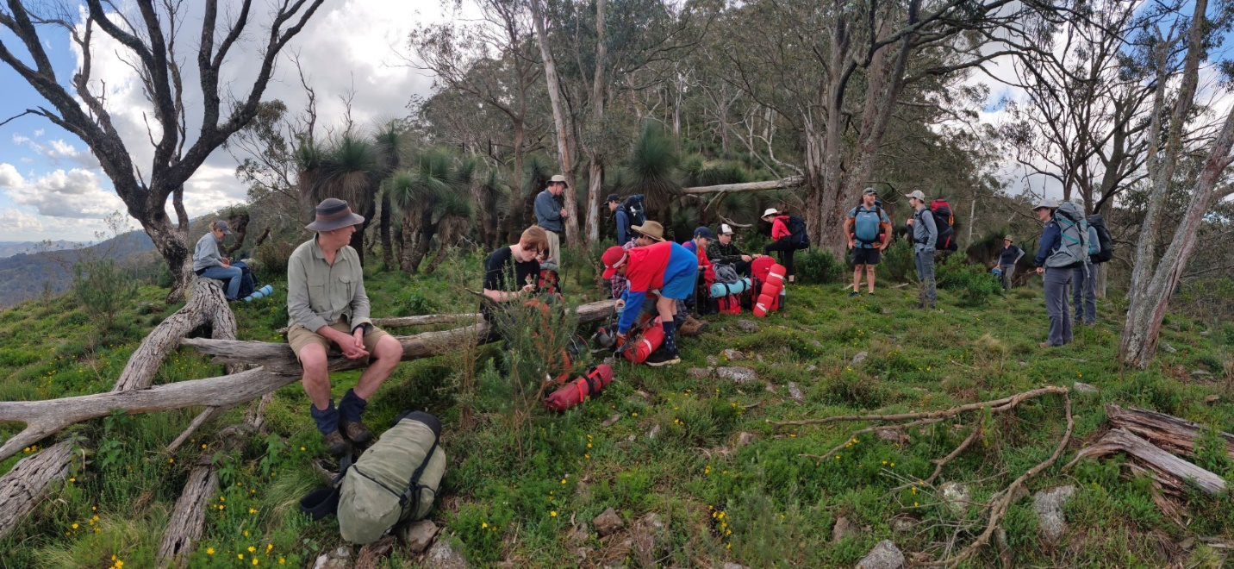

2022

We are writing to invite you to join our combined Scone Hike/Regional Bushwalking Practical. You have 2 ways you can do this hike…
- Regional Adventurous Activity Course - 2626 Bushwalking Upper Hunter
Cost: $15 ~ payable Scouts Aust (NSW)
Closing Date: 27 Aug 2026 (or until full)

See regional activities Events Calendar for information on all activities on offer across the year.
https://scoutreach.org.au/resources/activity-courses/

See Scout Events to register and pay for the course
https://events.nsw.scouts.com.au/region/hc
Each person can register individually, or you can register your group as bulk listing.

Bulk listings:- as you register each participant for this event, you will be asked to enter an email address for each applicant. That email address should belong to a parent if the applicant is under 18 years of age. Leaders should not use their own email address for legal reasons (unless of course you are registering yourself!).

Once all participants have been entered and you click SUBMIT, the system will generate a personalised email to each applicant which will include a unique link/login for the parent/participant to login to and complete their E-Permission Form and payment.

Once the E-Permission Form is complete, the system will send an email to the applicant with their completed form (PDF) attached. A copy of that email will also be sent to the person who registered the applicant.

Who: aimed at Venturers/Leaders who have done the three modules in e-learning Level 1 Bushwalking via Scout Central
https://training.scouts.com.au/curriculums/page-for-adventurous-activities and are seeking to complete the practical component.
Max: 12 participants in this section
- Hiking experience
Cost: Nil
Closing Date: 20 Aug 2026 (or until full)
Who: aimed at Scouts and those wanting to gain OAS 3-4 experience. Not aimed at absolute novice. Our general rule of thumb is you need to have successfully completed at least one decent (3-4 hour) day walk prior.
Max: 12 participants in this section
Contact: Greg Morris (see below) if your scouts are interested in this version of the hike.
Register: via Scout Hub Event https://1st-scone.group.scoutsnsw.com.au/events/349541 will only work for registered members ie you need to log into your Scout Hub profile then click on the link.

About the hike
Towarri National Park was created in 1998. Starting at Washpools Picnic Area at 450m it's an 850m rise to the top of the Liverpool Range. At 1100m elevation it’s a different environment that's for sure. Water from a mountain spring hidden in the bush. Across the plateau overlooking Murrurundi and the Great Divide - looking into the Liverpool Plains and on a clear day into Quirindi! Then do the 600m decent to the headwaters of the Pages River.

E1 form
The attached E1 form is a Scone Unit form. Whilst Scone Group will depart from Scone Scout Hall at 5:00pm on Friday 19 Sept, you are welcome to join us on Friday night or Saturday morning. Please modify the E1 form to match your group’s plans. You are welcome to stay at Scone Scout Hall on Friday night if that helps as well.

Transport
Because of the one-way nature of the hike – you will need to organise drop off and pick up parents. Please advise us of arrival time/day and any if need a hand with transport or can help others. Mudmaps supplied to those coming.

Scone troop runs a program throughout term 3 to prepare our scouts for our annual overnight hike – if you would like information about this let me know.

Hoping you can join us in this amazing part of the world.

Greg Morris
SL 1st Scone
0475 840 784
greg.morris@nsw.scouts.com.au
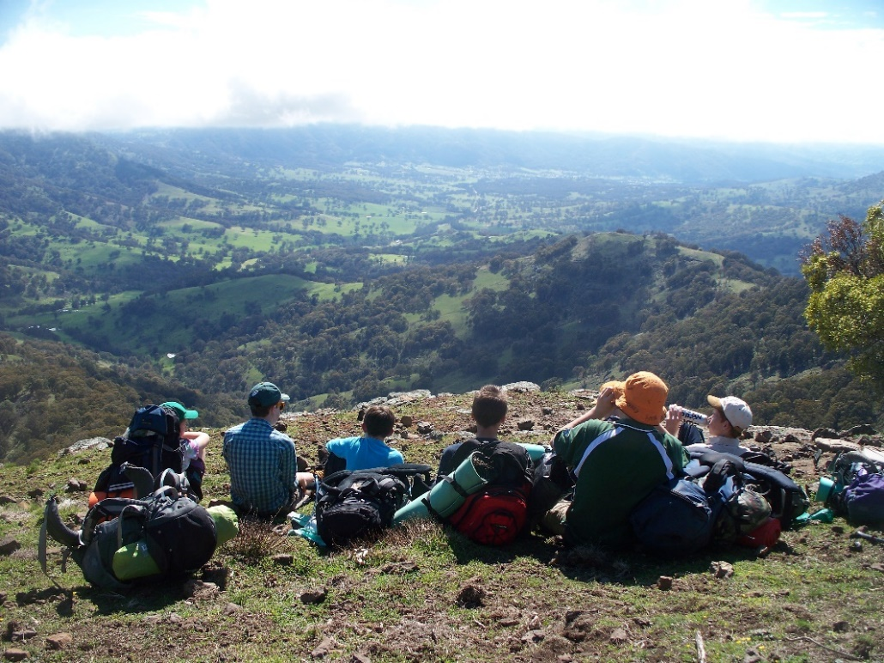
20th April 2026

2015
