Scouts Australia - New South Wales
HUNTER & COASTAL REGION
45 Cowper Street WALLSEND 2287
P O Box 191 WALLSEND 2287

Phone: (02) 4950 0999
E-mail: hc.region@nsw.scouts.com.au
Office Hours: Monday to Friday 8.00 am to 4.00 pm


Dear Participant

ALPINE WALKING at BARRINGTON TOPS # 2520

Saturday 13th to Sunday 14th June 2025

You have been accepted to participate in this event. The start is 10am Saturday at Polblue Camping Ground.

LOCATION: The Polblue Camping Ground is located on the Gloucester / Scone Road, approximately 65 kms from Gloucester and 20 kms from Moonan Brook.

START: 10am Saturday at Polblue Camping Ground.

FINISH: planned to be around 3 pm Sunday at Polblue Camping Ground.

MAPS: MOONAN BROOK & BARRINGTON TOPS (2017) - 1:25,000 topographic

OBJECTIVE - The aim of the weekend is to experience walking and camping in cold weather conditions. It provides an opportunity to practice the use of cold weather equipment, exercise safety procedures, enjoy the alpine environment, learn about cold weather cooking and camping. This weekend is to help gain experience in Alpine condition prior to learning other alpine activity such as cross country skiing. There will be plenty of discussion and opportunity for questions, working in small groups and hands-on activity.

The activity will involve bush walking on formed and unformed tracks between a series of navigation activities.

PREPARATION:
- Prior to the walk you should complete the attached navigation activity.
- It is advisable to have a dry set of clothes in your car for the trip home.

THE EVENT:
- You will be walking in small groups under the supervision of Alpine Walk Leaders.
- Saturday’s walk is via the first 6 checkpoints on the home work sheet. We will have lunch along the way, but won’t have time to cook.
- Once at camp we need to collect firewood and it’s advisable to cook and eat before it gets too dark and cold.
- Weather permitting time around the campfire is nice, but most times it’s too cold or wet.
- Sunday morning we will have a quick talk about tents before hiking to Brumlow Top (WP9), before returning to camp.
- A quick lunch, and then walk back to the start via a different route to the way we walked over.

Please Note: You should not have to walk any more than 20 kms (about 10k each day), unless we get geographically embarrassed, and there is a strong possibility of SNOW or RAIN; so Be Prepared.

COURSE LEADER – Tom Thorvaldson Please contact Tom on mobile 0402 822 093 or email on Tom.Thorvaldson@nsw.scouts.com.au if any additional information is required.

Please Note: Any Leaders applying for Skills days / weekend in Bushwalking this is NOT an accredited training course. If you wish to gain accreditation for Alpine or Bushwalking please refer to the RAT or State Training calendar for a BOS course near you. All accredited courses require eLearnlng prior to acceptance.

A few things for you to do:-
DONE?
Tick Off
1 | EQUIPMENT - you will need to bring your needs for the day including  - A backpack big enough to carry everything for the weekend  - A method of waterproofing your gear – the rain cover on your backpack only doesn’t cut it  - Food (Sat lunch, dinner, Sun breakfast, lunch, snacks, emergency rations)  - Mess kit and Cooking gear for Saturday night and Sunday breakfast – lunches won’t have time to be cooked.  - Water – at least 2 litres. Replenishment is from a creek at the campground – it is advisable to boil or treat before use.  - Trowel & toilet paper  - Homework sheet, maps that came with the homework, compass, pen & paper  - A good tent – or a share of one with your fellow venturers  - A sleeping mat to insulate you from the cold & potentially wet ground  - A below zero rated sleeping bag.  - Wet weather gear (jacket & pants).  - Good hiking boots – preferably waterproof.  - Layers of clothing: DO NOT BRING COTTON OR DENIM CLOTHING  - Hat for walking during the day, beanie &/or balaclava for the night  - Singlet or thermal, shirt, jumper, jacket  - Zip off pants are good, or shorts with thermals.  - Thermal pants are advisable for the campsite  - Dry socks and underwear for the 2nd day.  - Gaiters protect your legs from the wet and potentially sharp vegetation.

2 | DRESS - suitable for bush walking in cold conditions, and access to wet weather and insulating clothing (e.g. gloves, beanie etc.) and able to be identified as Scouts - scarf / group camp shirt / uniform etc.

3 | PEN AND PAPER - Bring note pad, writing implements and plenty of questions

4 | MAPPING EXERCISE – Will be undertaken on the day. But normally completed before the day, ask your Scout Leader to assist if you are not yet familiar with topographic maps. This will help in finding your way around a topographic walking map.

5  6 | HIKING EQUIPMENT – The purchase of a backpack, snow equipment and sleeping bag can be an expensive outlay. If you make the right choice these can last over 10 years and become a best purchase. This was discussed at the introduction day, but if you require assistance or advice, contact the course leader.  ANY CANCELLATIONS – if you are no longer able to attend this course please let the Region Office know on 4950-0999 before the activity commences or a refund will not be given. Please also let the Course Leader know.
7 | NPWS camping fee – this is through the NPWS. Each participant (or group) will need to book online. Go to “https://www.nationalparks.nsw.gov.au/camping-and-accommodation” and select “stay in a Tent” and “Remote / backpack camping”, and search for Little Murray campsite

The Regional Activity Team (RAT’s) look forward to having you on the activity and trust you find it both an enjoyable day and very useful as previous participants have found.

Yours in Scouting

Greg Denning
Regional Commissioner Activities
Per:

BARRINGTON ALPINE WALKING ACTIVITY COURSE

NAVIGATION PRACTICAL

PREPARATION HOMEWORK EXERCISE

Name ___________________________ Group _________________________

Date _____________________________

Please complete this navigation worksheet prior to the weekend – it will give you a better idea of where you are walking and the nature of the country. We will then compare it with what you find in the field.

Carefully plot the course on the attached map sheets – it would be good if you have it checked by a leader before the weekend – but do not just copy from someone else (this does not develop your navigation skills)

Before we start the walk, we will run through your answers and work out any differences – remember this is designed to develop your skills - not to give you a hard time.

Bring your compass to the weekend as you will be involved in the navigation work

NOTES

- MAP SHEET – Taken from MOONAN BROOK and BARRINGTON TOPS 1:25,000 – it is easier to work out things on the coloured map if you have one available.

- the attached map photocopies have been enlarged and are not at original map scale

- contour interval is 10 m and the magnetic variation is + 11.5 degrees

If you have any questions or need a hand, ask a leader or contact the course leader

WAY POINT  GRID REF | Height & feature(s) at point | Bearing (grid and magnetic) to next point | Distance to next point  (metres) | Briefly describe terrain and features along the route
 | Saturday morning
Start WP 1  513 632 | Ele = | Grid =  Mag = | Dist =
WP 2  518 629 | Ele = | Grid =  Mag = | Dist =
WP 3  516 622 | Ele = | Grid =  Mag = | Dist =
WP4  530 613 | Ele = | Grid =  Mag = | Dist =
 | Navigation exercise to Mt Polblue |  |  | RETURN TO PREVIOUS WAYPOINT (WP 4)
WP 5  532 616 | Ele = | Grid =  Mag = | Dist = | RETURN TO PREVIOUS WAYPOINT (WP 4)
 |  |  |  | CAMP SITE
WP 6  544 606 | Ele = | Grid =  Mag = | Dist = | CAMP SITE
 | Sunday morning
WP 7  545 602 | Ele = | Grid =  Mag = | Dist =
WP 8  536 590 | Ele = | Grid =  Mag = | Dist =
 | Navigation exercise to Brumlow Top |  |  | RETURN TO CAMPSITE
WP 9  534 582 | Ele = | Grid =  Mag = | Dist = | RETURN TO CAMPSITE
RETURN TO WP 1,
POLBLUE CAMPSITE
WP 10  530 613  (=WP 4) | Ele = | Grid =  Mag = | Dist = | RETURN TO WP 1,  POLBLUE CAMPSITE
WP 11  523 627 | Ele = | Grid =  Mag = | Dist = | RETURN TO WP 1,  POLBLUE CAMPSITE

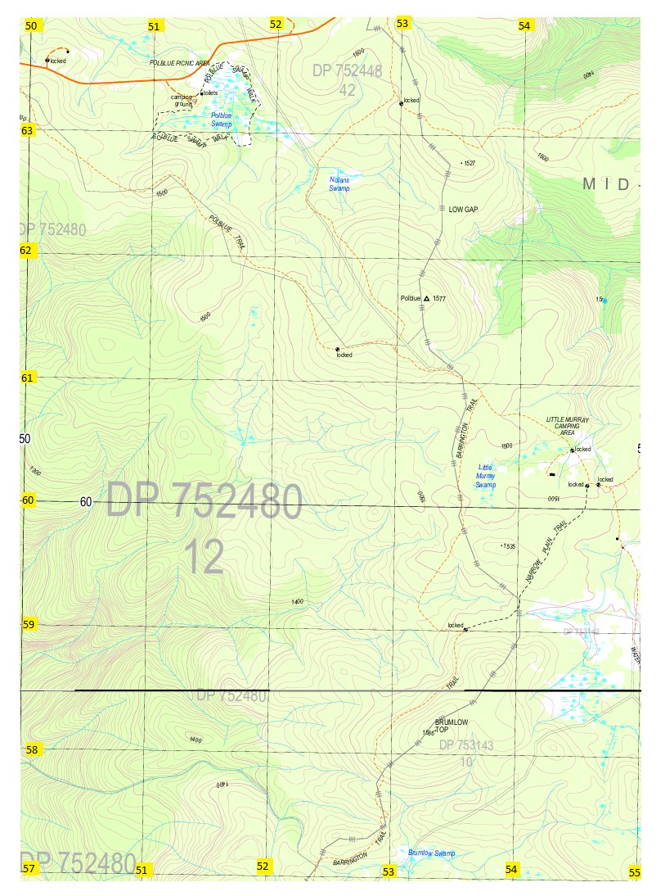
Taken from MOONAN BROOK and BARRINGTON TOPS 1:25,000 (2017)
Grid to Magnetic angle 11.5⁰ east (as of 2001), and moves easterly by less than 0.01⁰ per annum.

